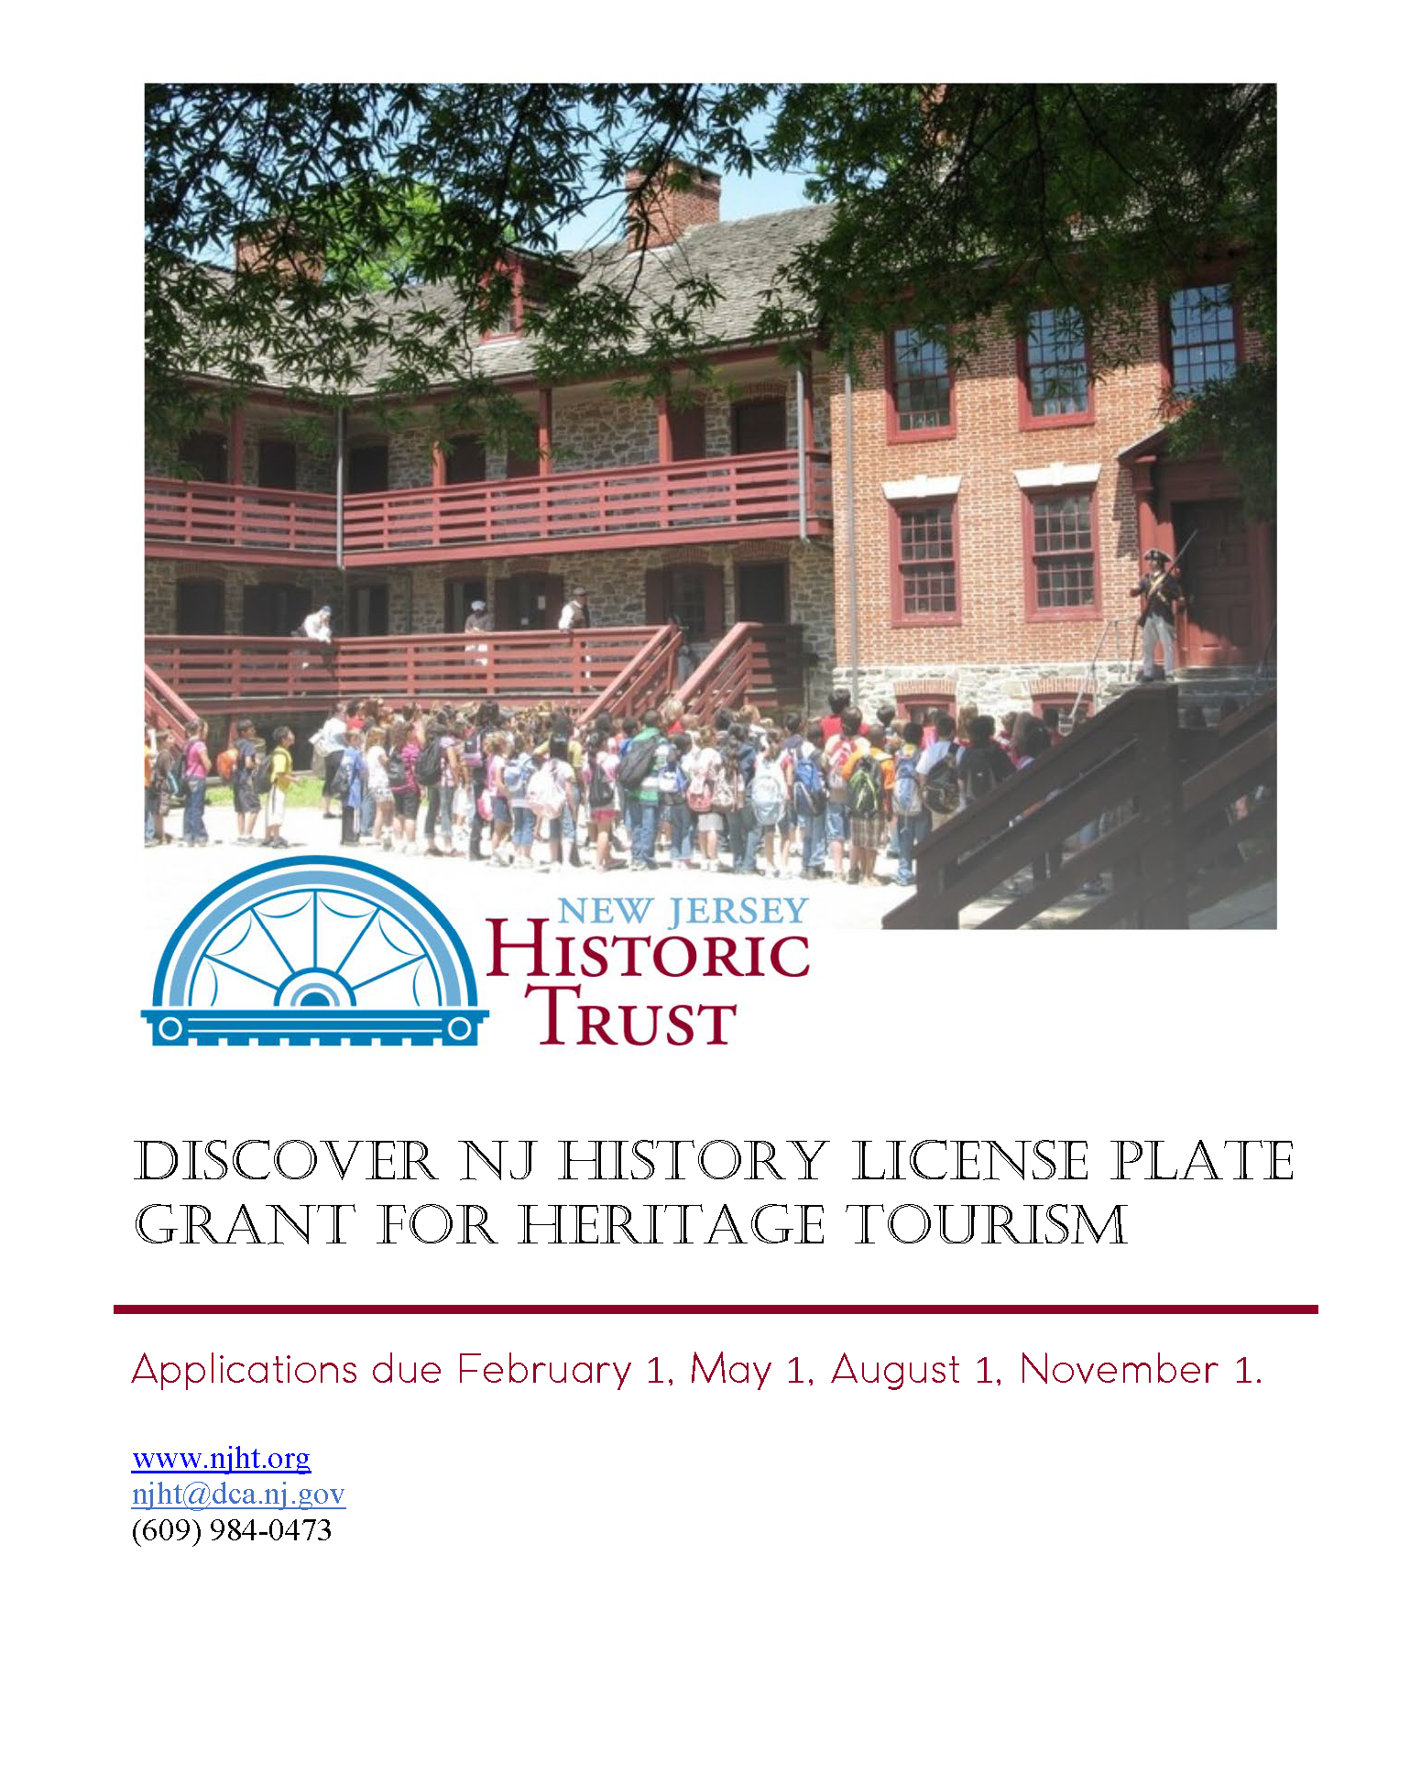

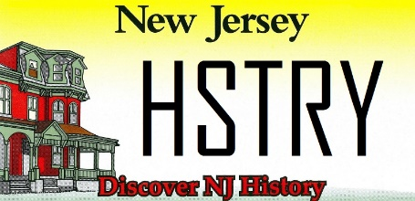

Instructions

All questions with an * are required. Some questions are only required if you gave a certain answer in a previous question. Those are denoted with a +.
Make sure to adhere to the maximum word limits on all questions. You will not be able to enter more than this in the online application, and evaluators will not consider answers that exceed the limit.
All applicants should read the Grant Guidelines (PDF) carefully before applying. The guidelines include important information about eligible applicants and activities, criteria for evaluation, schedule for review, and more.

Applicant Information

Applicant Contact Person First Name:*
Applicant Contact Person Last Name:*
Applicant Contact Person Phone Number:*
Applicant Contact Person Email:*
Applicant Organization Name:*
Organization Mailing Address:*
Organization Phone:*
Organization Email:*
Organization Website:
Organization Type:*
☐ Entity of County, Municipal, or State Government
☐ 501(c) Tax Exempt Organization
Federal EIN:*
+Required for 501(c) organizations only:
NJ Charitable Registration Number:

Property Information

The proposed project is for:*
☐ A single property or historic district
☐ Multiple properties

If this is application is for more than one property, please choose one property as the "primary site." You will be able to list all the properties in another question.
Primary Property Name:*

Physical property address:*
Property City:*
Property County:*
Property State:*
Property Zip Code:*

NJ Legislative District of the property (find your legislator):*
US Congressional District of the property (find your representative):*

+Required if multiple properties: Please list all properties below (name only).

Project Concept & Team

Project Title (ex. “Visitor Assessment for Historic Museum”):*

Describe the goals, anticipated outcomes, and how the proposed project will enhance heritage tourism opportunities.* (500word max)

How will this project benefit the identified historic resources?* (500 word max)

Is the proposed project an initiative to create a broader/regional heritage tourism plan or does the project implement part of an already existing regional plan?*
☐ Project is to create a regional plan
☐ Project implements an already existing plan
☐ Neither

+Required if project is to create a regional plan: Explain why the plan is needed, why this region or grouping of sites was chosen, what the anticipated outcomes are, and how the plan will be implemented once it is complete. (500 word max)

+Required if implementing an already existing plan: Identify the plan that this project is implementing, describe how this project fits in and how it forwards the goals of the plan. Please upload supporting documents, such as Heritage Tourism Master Plan, in the attachments section. (500 word max)

+Required if neither: Explain why this is a stand-alone project that is not part of a broader heritage tourism initiative. (500 word max)

Are consultant services proposed as part of this project?*
☐ Yes
☐ No

+Required if consultant selected: Name of consulting firm, if one has been chosen:

+Describe the role and services to be provided by the consultant. Please upload supporting documents, such as a proposal and resumes, in the attachments section. (250 word max)

What is the time frame for completing this project?* (250 word max) Example. Project kick-off in November 2024; Draft Visitor Assessment April 2025; Final Visitor Assessment September 2025; Presentation to the Board of Trustees October 2025.

How will this project enhance heritage tourism opportunities, linkages between sites, public awareness/participation, and interpretation of the resource(s)?* (500 word max)
Project Budget

Please enter all dollar amounts using the format $X,000.
Total project cost:*
Grant request:*

Provide an itemized project budget:*

If the total budget exceeds the grant request, please explain how you will raise the remaining funds. (500 word max)

Organizational Ability

Describe the mission of your organization and the audience it reaches. Explain the relationship of the proposed project to your mission and any planned program growth.* (500 word max)

Provide the names of the people who will be managing this project, their relationship to the organization, and what their role in this project will be. Please upload resumes in the attachments section.* (250 word max).

Identify any partner organizations and their role in the project, if applicable.

Public Access & Benefit

Is the resource open to the public on a regular basis?*
☐ Yes
☐ No
+Required if no: Explain why not. (250 words max)

Current hours of operation:*

Is there an entry fee?*
☐ Yes
☐ No
+Required if yes: What is the entry fee?*

How will the project benefit the community? Who will benefit from the results?* (500 word max)

How will the success of this initiative be measured?* (500 word max)

Is the resource, or any resource within the project boundaries, included on Journey Through Jersey?*
☐ Yes
☐ No
☐ Nomination Submitted

Attachments
Project Concept & Team:
☐ If applicable, upload the broader heritage tourism plan or agenda this project supports. (one file max)
☐ Upload any supporting documents related to consultant services, including by not limited to, proposals and resumes. (five files max)

Organizational Ability:
☐ Upload resume(s) of project coordinator and pertinent staff/board/volunteers (five files max)

Miscellaneous:
☐ Provide any additional documentation such as design of brochure or signage, product specification sheet, tourism assessment, etc. (five files max)

